

Dungeon AR Design Document

By
Alpaca Studios

Document Contents

1 Concept Document 1
1.1 Title Page 1
1.2 Credit Page 1
1.3 Sign-Off 1
1.4 Introduction 1
1.5 Game Analysis 1
1.6 Game Play 1
1.7 Key Features 2
1.8 Selling Features 2
2 Design Document 3
2.1 Design Guidelines 3
2.2 Game Design Definitions 3
2.2.1 Player Definition 3
2.2.2 User Interface (UI) 3
2.3 Global Game Elements 4
2.4 The Story 4
2.5 Level Design 5
2.6 Audio & Sound F/X 6
2.7 Game Architecture 6
Technical Document 7
2.8 System Requirements 7
2.9 Visual Content 7
2.10 Audio Content 7
2.11 Programming Content 7
2.12 Code Structure 8
2.13 Concerns and Alternatives 8
2.14 Resources 8

Concept Document

Title Page
This document provides information on the concept, design and technical aspects of the AR tool with the working title Dungeon AR. The concept document should remain largely untouched as with the technical document without consent from the team, the design document is a living document and may be updated as new information is provided, especially player feedback.

Credit Page

Document Purpose: | Oversight and specification for the development of the Dungeon AR project.
Document Version: | 1.1
Working Title: | Dungeon AR
Game Concept: | An AR tool to promote visualisation in tabletop and pen & paper role playing games
Game Document Author: | Michael Curtis, Lewis Wilden, Callum J Walsh

Sign-Off
This section is here to confirm that each team leader has read through the design and agrees with the current game design.

Game Design Sign-off

Callum Walsh:
Lewis Wilden:
Michael Curtis:

Introduction
The application is a tool to be used in tabletop and pen and paper roleplaying games as to add visualisation of rooms and monsters to games such as Dungeons and Dragons and Pathfinder in order to increase immersion and aid the game master in creating a narrative whether their own or from source material.
Players will see cards with unique images corresponding to different rooms that are held as 3D models within the application and when scanned using a mobile device operating the application will present the models in augmented reality using AR core or AR kit (Android or iOS respectively) for players to view and look around.
We consider this a unique solution to enhancing roleplaying games while maintaining the level of flexibility in the theme that allows it to be used for multiple games (e.g. Pathfinder) as well as many permutations of campaigns within these games so that the players and especially the game master has complete control over the direction of the narrative (i.e. avoiding railroading other people’s narratives with the assets that are provided).

Game Analysis
Game Description
Genre: | A tool that allows for the following genres  - Role-play directed by the GM  - Adventure directed by the GM  - Some Puzzle elements directed by the GM  - Augmented Reality
Game Elements: | - Scanning Cards  - Viewing projected 3D models  - Rotation of either all assets are at least all non-open plan assets (entities)  - Setting up cards for the adventure (GM Only)

Game Content: | At Game Masters discretion with assets available, additional packs will be created for the application so that the GM has more tools at their disposal
Theme: | Initial theme is fantasy dungeons however additional packs will address new themes (e.g. Sci-fi, Taverns, Western, etc)
Style: | Realistic within the setting
Player: | Any number of players either each with their own devices or sharing devices
Game Reference
Player Immersion: | This application is a tool for the Game Master and level of immersion is generally up to them and their abilities although it is imperative that usage of the application is a streamlined as possible to reduce wasted time.

Game Technical
Technical Form: | - 3D graphics presented in Augmented Reality through a mobile device
View: | - Various depending on angle of device toward 3D models
Platform: | - Unreal Engine (Blueprint primarily, C++ as required), utilizing AR core primarily (AR kit where required)
Device: | - Mobile Devices
Game Sales
Consumer Group: | - Roleplaying gamers of all kinds
Payment: | - This application has a pay structure different to standard. The application is free to download therefore avoiding the potential for pirating, however the application requires cards with unique images, also to avoid pirating these cards are free to download from our website as pdf’s and players can print them off freely. However we will also be selling high quality physical copies of the card for delivery for convenience and quality, this model has been done very successfully by the card game Cards against Humanity.
Estimated Price: | - TO BE DETERMINED  - Consider cost of production, Delivery, Order Management and packaging
Device Support List | - Android 8+ that has AR core support  - iOS devices that support AR kit (iPhone SE and later)

Game Play
Firstly, the Game Master would plan his campaign based on their own narrative or one from existing source material and the order in which they want to use the cards for key points of the campaign that they wish other players to visualise. At this point the GM can either lay the cards out in order, or keep the order hidden and reveal them as they wish.
Other players simply scan the codes on the cards with their devices as and when the GM wishes and freely view the model and integrate with it as with any other element of a roleplaying game with the GM providing narrative, gameplay and exposition.

Example: Players campaign through a tunnel through generic roleplaying processes and the players stumble upon an altar. At this point the GM flips over the Altar card and allows players to scan the card in order to visualize the card, the GM can now continue to describe events within the room while being able to refer to specific areas and geometry that all players can now see.

Key Features
The key features of the application are the following:
- Multiple different virtual rooms as 3D Models with quality textures
- Multiple different entities as 3D models with quality textures and looping idle animations
- Flexibility for the tool to be used with multiple scenarios
- Must work well on mobile devices
- Must be very easy to use and require minimal time investment

Selling Features
This is a unique application because it enhances the roleplaying experience by adding digital visualisation easily without compromising creativity and the unique campaigns that can make roleplaying games so appealing.

Design Document

Design Guidelines
Constrictions to the design of the application are as follows:
Technical
- Must run well on benchmark mobile devices that support AR core or AR kit
- Must require a minimal time investment to scan and show 3D assets
- Must have images that are easy to scan and quickly recognised
- Assets must be scaled appropriately so that they do not use an entire play area to view but also allow players to move around them
- Must be able to see all angles of assets from a still position, either through rotation (entities) or open planned designs (rooms)
Design
- The artwork must not railroad a GM’s narrative into a pre-set one
- The rooms must not contain specific objects such as enemies or rewards only geometry
- Geometry must not directly link to any specific roleplaying game as to allow it to work well with as many as possible
- Geometry must not imply a specific path for players to follow
- All assets must be large enough for appropriate scaling as per technical requirements
- All assets provided must interesting enough to warrant being added to a story (e.g. no empty corridors or blank rooms)

Game Design Definitions
The following aspects are defined elements of game play:
- Menu before main application
- Scanning cards to produce 3D assets
- Rotation of non-open plan objects (entities rather than rooms)
- Removal of projected assets on command
- The focus of play is visualisation of areas and in some cases entities for capitalisation by the GM to further immersion and narrative

Player Definition
What does the player do?
- Scan cards
- Rotate some assets
- View assets
- Clear Assets

User Interface (UI)
The UI will be very minimal, on launch a main menu appears with a start button and potentially a mute button if audio is required (see Audio).
The main screen which is opened on pressing start is mostly clear, with a scan button dominating the bottom of the screen, this commands the application to try and recognise an on-screen image to spawn an asset from. On the left of the scan button exists a smaller clear button which on press removes all assets from the scene. On the right of the scan button is potentially a mute/unmute button if audio is required (see Audio). In the centre of the screen is a simple crosshair to allow provide assurance to players that the image they are scanning is in the centre of the screen.
Additionally, an unseen element of the user interface is the ability to rotate non-open plan objects (i.e. entities) by pressing and dragging in the direction they wish to rotate it.
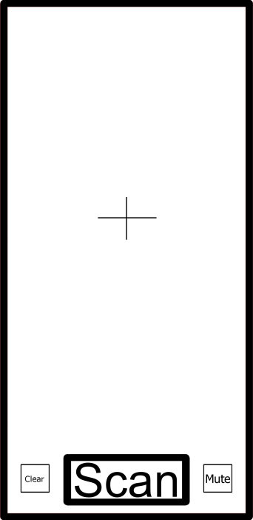

Global Game Elements
Scale of all objects must be consistent, this scale must also not be too large as to be difficult to place other assets around, while also being large enough for players to view comfortably without needing to get very close just to see the geometry.
Objects must also be anchored to the card they have spawned from and not move when the player moves.
Objects that are not open plan (specifically entities) should be rotatable by players.

The Story
The story of the “game” is specifically not contained within the application as to provide complete narrative control to the GM and the specific roleplaying game mechanics that are used by the players. Just as implementing a story is important to many games, the intentional removal of a story is just as important to this application.
However, it is important that assets provided are interesting enough to warrant being added to a story devised by other people therefore rooms and entities that could be considered boring, or at least not worth spending time scanning and viewing are to be strictly ignored.

Level Design
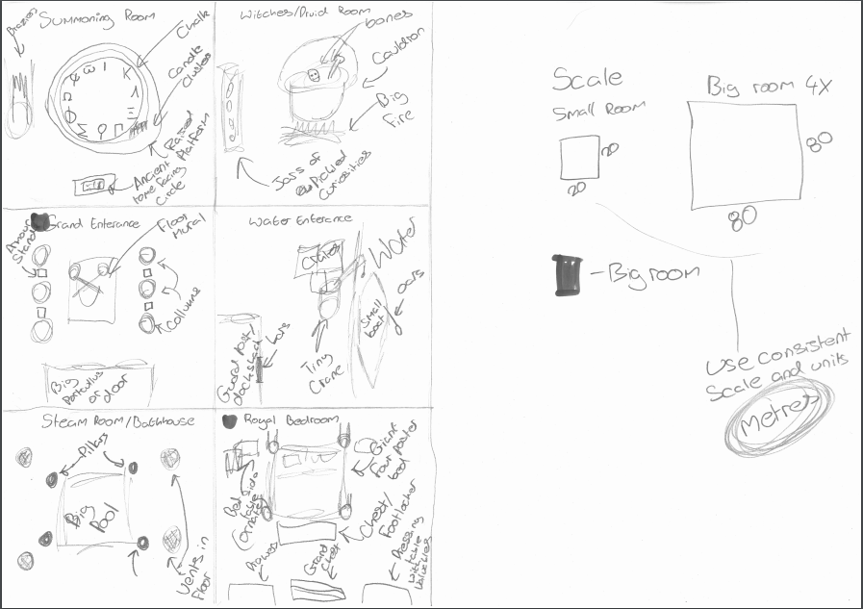
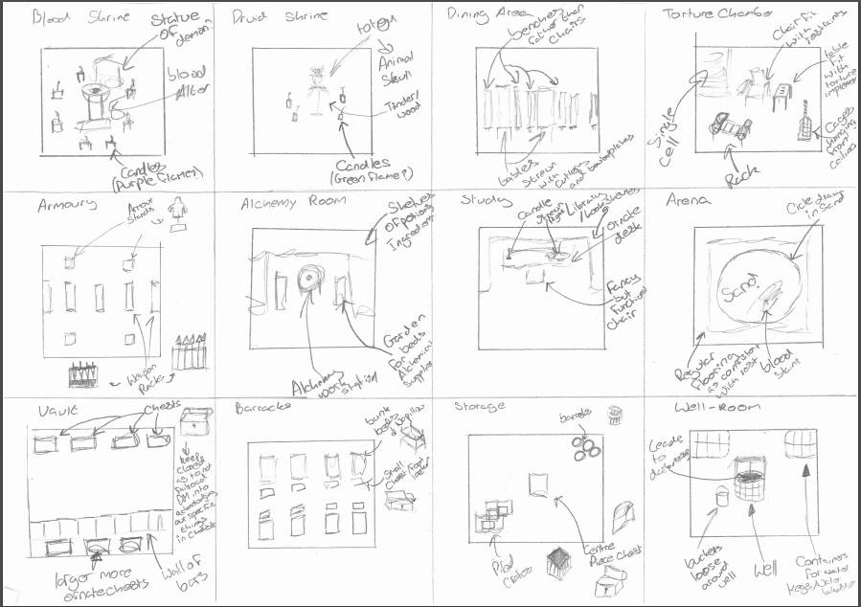
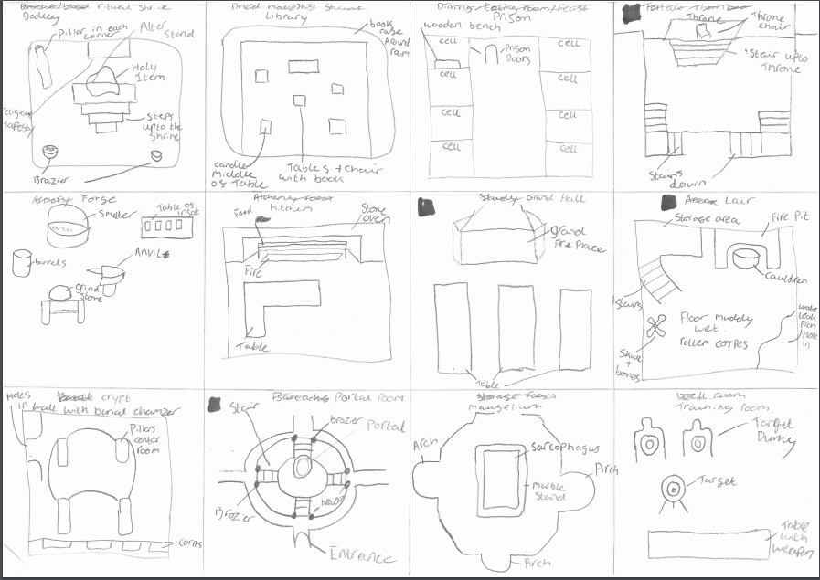

Audio & Sound F/X

FUTURE ADDITION/TO BE DECIDED

Game Architecture
A main menu that opens into the main game screen, these are the only scene changes required.

Technical Document

System Requirements
The benchmark device is a Samsung galaxy A50,
Each mobile device requires at least android 8.0 and must be able to run AR core.

Visual Content
- General
  - Texture Size 512x512
  - PNG
  - As high as a phone is capable
- Heads Up Display (HUD)
  - Crosshair
- Global Elements
  - Rooms
  - Entities

Audio Content
TO BE DECIDED
- General
  - File Size Restrictions
  - File Format Type
  - File Quality Type
- Player Elements
  - Type of Sound f/x
  - Device Vibration
- Antagonistic Elements
  - Type of Sound f/x
  - Device Vibration
- Global Elements
  - Ambient Music
- Splash Screens
  - Ambient Music
- Menus
  - Type of Sound f/x

Programming Content
- General
  - Database handling
  - Unreal File
  - Blueprint primarily/C++ when required
  - Mobile
- Player Elements
  - Spawning rooms/entities
  - Rotation of entities
- Splash Screens
  - Potential loading screen between main menu and play screen
- Menus
  - Main Menu

Code Structure
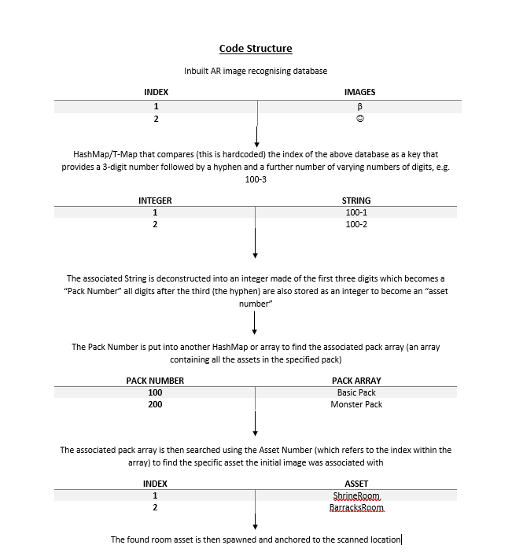

Concerns and Alternatives
- Some C++ maybe required
- Automated updating of databases
- Phone hardware
- Compatibility of database searches

Resources
All software must conform to the software listed in the license document.

